P a g e | 1

Business Continuity Plan

Create Learning Trust



Approved by | Date | Review Schedule | Date of Review
Board of Trustees | November 2025 | Annually | November 2026

N
Create Learning Trust is a limited company by guarantee | Registered in England 11727632 | Registered Office: Little Leigh Primary School
CREATE LEARNING TRUST
The Board of Create Learning Trust has adopted this policy (November 2026). It will be reviewed annually by the Board of Trustees.

Table of Contents
1.0 Introduction 3
2.0 Definitions 3
3.0 General Information 3
3.1 Review and Training 3
3.2 Associated Documents/information 3
3.3 Emergency Contact Information 3
4.0 Strategy 4
5.0 Roles and Responsibilities 4
5.1 Headteacher or their Deputy 4
5.2 Incident Management Team (IMT) 4
5.3 Staff 5
6.0 Procedure for Closing the Trust Schools 5
6.1 Closure in advance of a School day 5
6.2 Closure during a School Day 5
6.3 Immediate Places of Safety 5
6.4 Off-Site Place of Safety 7
7.0 Lockdown Procedure 7
8.0 Business Recovery in the Event of a Loss of Buildings or site Space 7
8.1 General 7
8.2 Insurance 7
8.3 Replacement Site Facilities 7
8.4 Paper Based Records 8
8.5 Remote Learning 8
9.0 Flooding 8
10.0 Other Threats 8
11.0 Draft Recovery Action Plans 9

1.0 Introduction
This Business Continuity Plan (BCP) has been written for those who will be involved in re- establishing the operational delivery of services following a major incident. It should be read in conjunction with:
- The individual school site business continuity plan.
- The School’s fire evacuation plan (the operation of which does not necessarily activate the BCP).

2.0 Definitions
An emergency is any event which causes, or has the potential to cause injury, loss of life, damage to property or significant business disruption.
A disaster is the escalation of an emergency to the point where normal conditions are not expected to be recovered for at least 24 hours.

3.0 General Information

3.1 Review and Training
This document should be reviewed annually by the CLT trust board and circulated to the local academy board of each school in Create Learning Trust.
Training for staff on evacuation procedures should be included within the School’s half termly fire drill and mustering. This information should also be included in the schools fire evacuation plan.

3.2 Associated Documents/information
Associated Documents include:

- Fire Evacuation Plans
- Fire risk assessment
- Snow Chain
- Unavoidable School Closure
- Severe Weather Guidance
- Bomb Threat Guidance
- Health and Safety including Asbestos Management Plan
- Fire Safety Log Book and Premise Management Records
- COSHH Register

These documents should be backed up electronically.

3.3 Emergency Contact Information
An emergency information pack is kept at reception and includes:
- Copies of this document
- The snow chain
- Contact phone numbers for local radio stations, details of access to communication media by each school (for example, Website, Instagram, Text Messaging service using school comms method, Arbor etc)
- Local Services - Medical Centre/Hospital/GP surgery, Local Police Station, Local Fire Station
Access to staff and student data (those on roll) with home phone numbers can be accessed by Arbor. This data can be accessed remotely from any device with an internet connection.

4.0 Strategy
If a disaster is declared by a CLT school’s Headteacher or their designated deputy, the CLT Business Continuity Plan will be activated alongside the schools individual disaster recovery plan. All Schools have an individual Business Continuity Plan.
Staff communication will be via email and the website if this is operable, or by use of the snow plan telephone lists if not. Other forms of messaging such as text messaging will also be utilised.
The following organisations may need to be advised of the implementation of the Business Continuity Plan as soon as possible:
Jeanne Fairbrother Associates – 07592413532 (Neil Thomas) & 07834189236 (Jeanne Fairbrother)
247 Technology – 03338000274 & 07787425759 (Steven Mowat – IT Manager)
RPA Insurance - Email RPA.CM@davies-group.com or Call 03300 585566 (emergency incidents).
Health and Safety Executive (HSE) - 0345 300 9923

5.0 Roles and Responsibilities

5.1 Headteacher or their Deputy
The Headteacher is responsible for the implementation and co-ordination of the BCP, including:
- Immediately contacting the CLT Operations Director, JFA and 247 Techonolgy IT, if the disaster relates to the built environment or the ICT infrastructure to establish if the building can be re- occupied and/or service delivery reinstated.
- Co-ordination of status reports/communication for the benefit of all audiences
(including staff, students, parents, LA, Academies Team at DFE, press)
- Maintaining the school’s BCP in an up-to-date format by delegating responsibility to the CLT central team for updates.

5.2 Incident Management Team (IMT)
Lead by the Headteacher, the Incident Management Team includes all Deputy
Headteachers and the Site
Manager/Maintenance officers. Additional members of the team will be recruited to match the specific needs of the incident. The CLT CEO and Director of Operations must also be informed.
The IMT is responsible for acting under the direction of the Headteacher (or their Deputy) to restore normal conditions as soon as possible. This IMT may also be lead by the CLT CEO.
All decisions and subsequent actions are to be logged in order to have a record of events and communication made to support services.

5.3 Staff
Staff are required to co-operate with the IMT in support of the BCP.
In the event that staff are sent home, they should remain available during normal working hours to assist with necessary tasks. This may include remote working.

6.0 Procedure for Closing the Trust School’s

6.1 Closure in advance of a School day
The school can be closed in advance of a normal school day using the following system:
- Closure authorised by the Headteacher or their Deputy, with the support of Jeanne Fairbrother associates if this closure relates to a health and safety concern. The Chair of the Local Goverance Committee should also be part of this conversation.
- Notification of a school closure using the Local Authority On-line website (actioned by Headteacher).
- Implementing the school staff ‘snow chain’ (actioned by – Senior Leadership Team)
- Recording the closure on the home page of the school website (actioned by – school admin team)
- Sending out text messages via to all parents (actioned by –school admin team).

6.2 Closure during a School Day

It is never a preferred option to close the school during a school day but it can be done using the following procedures:

- Closure authorised by the Headteacher or their Deputy. Students will continue to be supervised by staff until parents authorise them to leave or they are collected.
  - Parental authorisation can be provided by telephone conversation with parent or email notification only.
  - Consider use of Places of Safety (as described below).
- Recording the closure on the home page of the school website (actioned by – admin team).
- Sending out text messages to all parents (actioned by – admin team).
- Consider posting on social media page – Twitter/X or Facebook

6.3 Immediate Places of Safety

In the event of a major incident on site requiring the school to be closed, students will assemble at the primary assembly points. If these are not useable staff will escort students to the secondary assembly points.

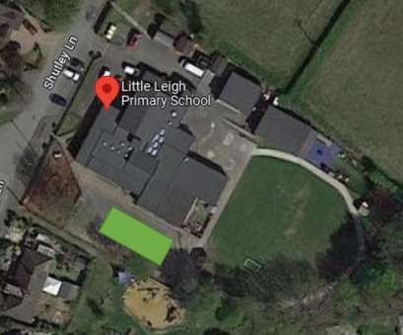

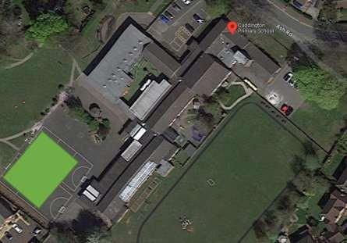

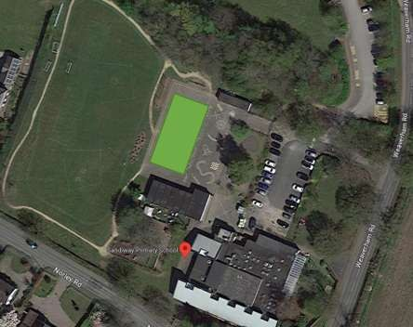
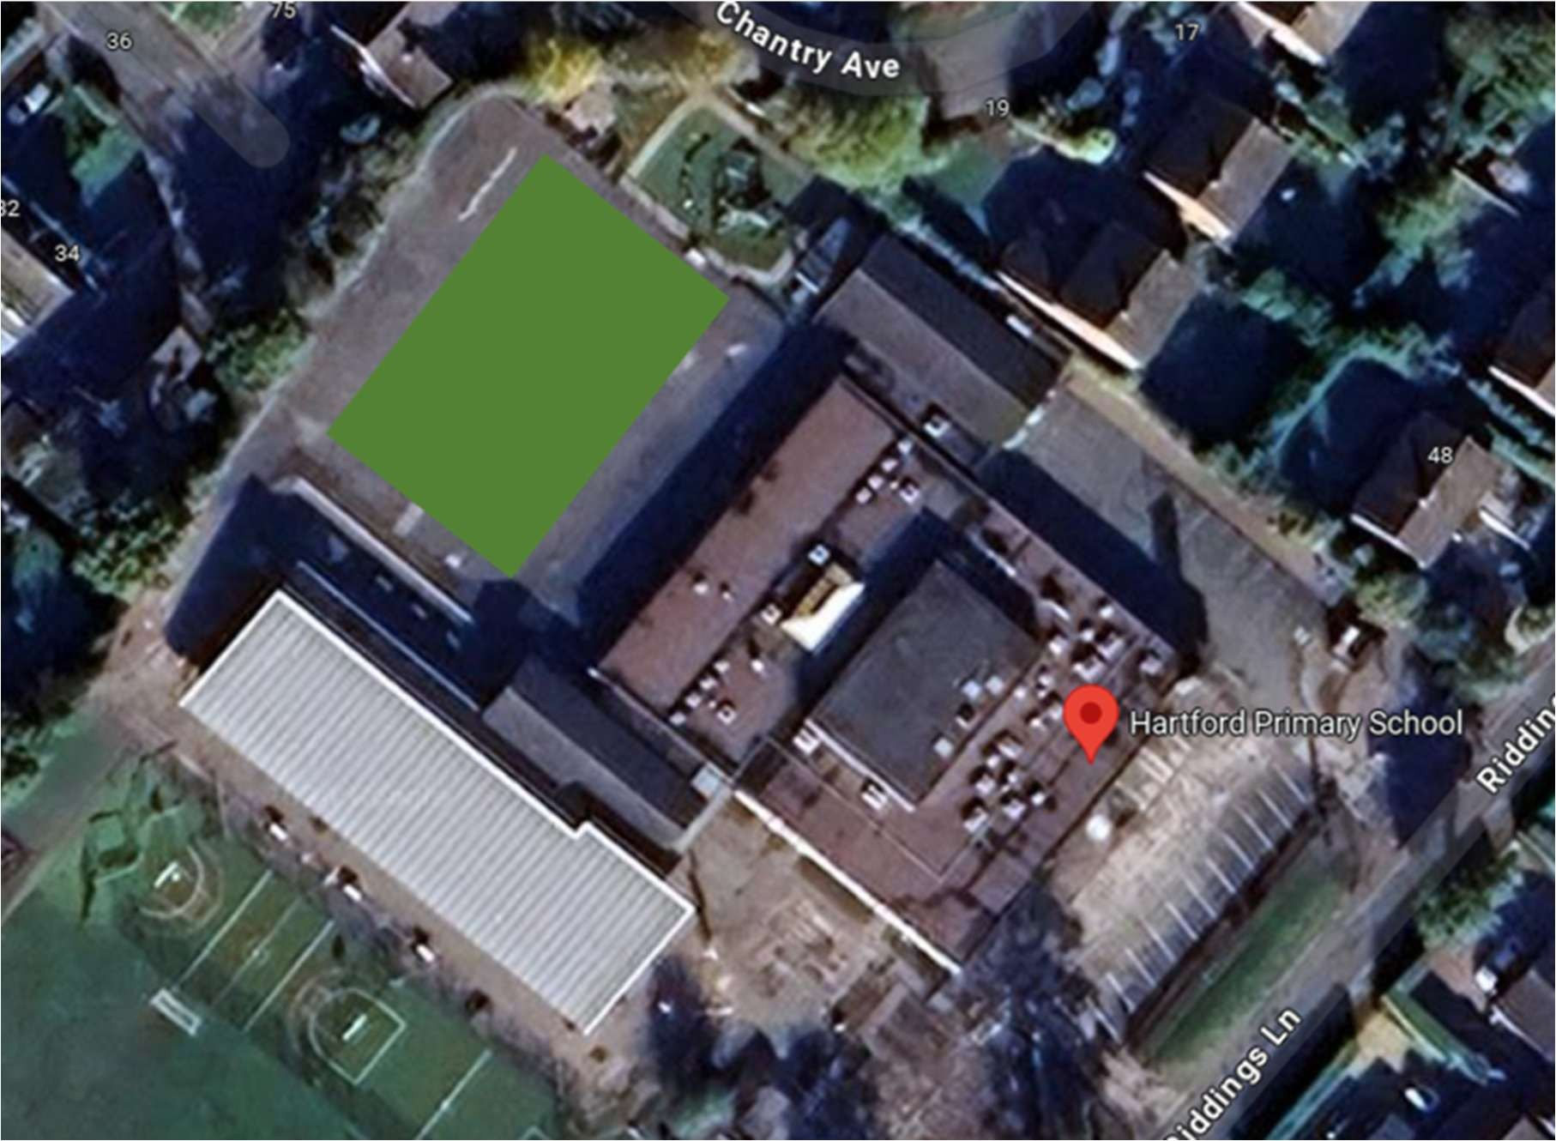
Maps of all four schools in Create Learning Trust are shown above. The area highlighted in green shows the on-site assembly point.

6.4 Off-Site Place of Safety
If it becomes necessary to evacuate the site completely, students will be escorted into the safety grounds for each school where they can be collected or from where they can be
released to make their own way home.

7.0 Lockdown Procedure
It is now possible to envisage circumstances where the school may wish to lock itself in, to secure staff and students from an outside threat. This circumstance is described as a ‘lockdown’.
If a lockdown is declared, the Head teacher/Site Manager of each school site will be advised to implement the site specific lockdown procedure, created and approved in the Autumn term at local governance level. All schools have an individual lockdown procedure.

8.0 Business Recovery in the Event of a Loss of Buildings or site Space

8.1 General
Replacement of the buildings and facilities that have been damaged or made unavailable will be the responsibility of the DfE and Create Learning Trust. In the event of building unavailability, the school should be covered under their insurance policy for reinstatement costs and temporary accommodation costs.

Temporary working facilities are the responsibility of the School and Academy Trust for which it holds insurance (see below).

8.2 Insurance
The schools hold insurance with the Risk Protection Arrangement for Schools (RPA). Guidance as to the level of insurance provided by the RPA under the insurance scheme for temporary accommodation can be found using the following link - https://www.gov.uk/guidance/the-risk-protection-arrangement-rpa-for-schools.

8.3 Replacement Site Facilities
The size and scope of facilities required for the school will vary according to circumstance. In the first instance contact should be made with the RPA Insurance using the contact details below:

For emergencies and urgent incidents (excluding overseas travel)
Email RPA.CM@davies-group.com

Call 03300 585566

For overseas travel emergencies and urgent incidents
Call 020 3475 5031
The location of the temporary accommodation will be determined based on the space required and circumstances at the time. Two possible locations that have been identified for consideration should temporary accommodation / buildings need to be sited are:

- St Michael & All Angels Church, Little Leigh – Little Leigh Primary School students and staff
- Sandiway Church – Cuddington Primary School students and staff, Sandiway Primary School students and staff
- St John’s Church, Hartford – Hartford Primary School students and staff

Erecting additional buildings on our current campus site will always be the preferred solution.

8.4 Paper Based Records
Important paper-based records such as staff personnel files and pupil record folders should be kept in a secure location (e.g. a fire-proof safe).

8.5 Remote Learning

Head Teachers should Initiate and make arrangements for pupils to access remote learning as part of the business continuity plan. Communication must take place via the school’s teacher to parent messaging system.

9.0 Flooding
Follow BCP procedures in the event of flooding on the school grounds, in the school premises or within the local area which may affect the normal running of the school.
Notification of actual or potential flooding could come from a variety of sources, such as: Receipt of an Environment Agency Flood Alert / Flood Warning / Severe Flood
Warning;
Local trigger, such as river levels; Reports of actual flooding;
Met Office weather reports.

10.0 Other Threats
The following Other Threats may need to be considered, and a brief description of possible scenario and action to be taken documented.

Phone and ICT Communications Loss
Finance Process Breakdown – payments to staff & suppliers fail
Utilities / Energy Supply failure
Service Delivery Loss of General Nature – CLT are unable to provide buildings or ICT support
Key Supplier Failure other than CLT – Cleaning, Catering, transport
Evacuation due to Nearby Incident
Bad Weather prolonged
Strikes
Terrorist Attack or Threat

P a g e | 10

11.0 Draft Recovery Action Plans

Operational Threat | Steps to Restore Normal Working | Action by Whom | Comments/Notes
Phone and ICT Communications  Loss | 1.
Finance Process Breakdown – payments to staff & suppliers fail | 1.
Utilities / Energy Supply failure | 1.
Building Loss – partial or complete (Fire, Flood etc.) | 1.
Building Denial leading to short term lack of access | 1.
Service Delivery Loss of General Nature – CLT are unable to provide buildings or ICT support | 1.
Key Supplier Failure other than  CLT– e.g. Cleaning,  Catering, transport | 1.
Evacuation due to Nearby Incident | 1.
Lockdown due to Nearby Incident | 1.
Fire | 1.
Bad Weather prolonged | 1.
Strikes | 1.
Terrorist Attack or Threat | 1.

P a g e | 11

Contact details

Chief Executive Officer | Sarah Woodward ceo@createlearning.co.uk 01270 360030
Chair of the Trust | Faye Russell frussell@createlearning.co.uk 01270 360030
Chief Finance Officer | Jenni Goodwin cfo@createlearning.co.uk 01270 360030
Trust Solicitor | Cook Lawyers www.cooklawyers.co.uk / 01625 725 000
Clerk to governance | Julie White (Second2None)
Chair of Sandiway LGC | Emma Zouhbi ezouhbi@sandiway.cheshire.sch.uk  Sandiway Primary School, 84 Weaverham Road, Sandiway CW8 2ND
Headteacher at Sandiway Primary School | Kathryn Harvey  head@sandiway.cheshire.sch.uk
Chair of Cuddington LGC | Emma Zouhbi ezouhbi@sandiway.cheshire.sch.uk  Cuddington Primary School, Ash Road, Cuddington CW8 2NY
Executive Headteacher at Cuddington Primary School | Beth Hacking  head@cuddington.cheshire.sch.uk
Chair of Little Leigh LGC | Ryan Tomlinson  rtomlinson@littleleighprimary.cheshire.sch.uk Little Leigh Primary School, Shutley Lane, Little Leigh, Northwich CW8 4RN
Head of School at Little Leigh Primary School | Rebecca Challinor  head@littleleighprimary.cheshire.sch.uk
Chair of Hartford LGC | Katherine Ottewell  kottewell@createlearning.co.uk  Hartford Primary School, Riddings Lane, Hartford CW8 1NA
Headteacher at Hartford Primary School | Lindsay Cade  head@hartfordprimary.cheshire.sch.uk
Create Learning Trust Offices | Cuddington Primary School, Ash Road, Cuddington CW8 2NY

